Think Sheet 1: La Sagrada Familia
La Sagrada Familia looks like a painting the artist could not stop touching—a new line here, another splotch of paint there, the oil building upon the smooth canvas until it develops a complex, organic texture. Looking at the contemporary Nativity Façade one is taken aback by the maximalism, indulgence, and ordered chaos that reflect the Creator it honors. But it did not begin that way. Take a look at the façade in 1899₁. Behind the scaffolding the shape is dominated by concavity. While this clear-cut molding pays tribute to the gothic style from which the late head architect Gaudí derived his own, over decades the façade became increasingly dominated by ornamentation₂. And as ornamentation grew with time, so did a contrast between the organic, intricately textured solids plastered onto the façade and the geometrical, traditional concave structure that served as its foundation. The interplay between the concave structure and protruding ornamentation is disorienting, but, as Rasmussen notes in a nod to Michelangelo’s Porta Pia, this effect may serve to “accentuate certain parts of the work” (59). And it certainly does. The angels decorating the façade literally protrude from the depths of the structure, perhaps metaphorically emerging as light from a dark, shadowy space, reinforcing their meaning in a religious context. The contrast between the concavity and ornamental figures of the façade redefines the meaning of these figures in a way that greater fulfills their purpose in the cathedral.
But perhaps a binary contrast between the past and present is not the most effective model to understand La Sagrada Familia. The Nativity Façade, and the cathedral on the whole, did not begin in one form and then spontaneously emerge in its contemporary form. Rather, the form evolved over time, reflecting the history of the world it inhabits and the mortality of its architects.
Today’s head architect, Jordí Faulí, recalls that Gaudí “knew he would not finish”₃. Gaudí had accepted his own mortality and left behind many plans. But perhaps, more than accept, Gaudí sought to leverage the lengthy construction of the cathedral to capture a sort of rhythm over time—a type of rhythm that is seldom seen in architecture.
Rasmussen notes musical rhythm and architectural rhythm are different, though their mathematical structures are the same (105). Rasmussen does not use this language, but I suspect what he means is that, in music, we observe rhythm as a function of time, whereas in architecture rhythm is a function of space. But with its enduring construction, La Sagrada Familia captures a type of organic rhythm of the cathedral’s form over time, much like music. The cathedral’s form waxes and wanes, in doing so reflecting the history of the society it reflects. It is littered with scaffolding for certain periods then emerges with greater ornamentation, only to resume construction again. It grows in perfection until events like the Spanish Civil War or coronavirus pandemic stall or decline progress with the organic regularity of western civilization. Its style oscillates with the mortality of its architects though remains stable along its approach to an ultimate aesthetic goal. These rhythms and patterns over time not only capture but allow us to engage in—as a locus in this strange sinusoidal artistic trajectory—Gaudí’s neo-gothic aesthetic. This aesthetic itself is marked by transition—transition over time—from medieval gothic forms to modern clutter and sleek geometry, and only by experiencing this transition over time—by watching the angels emerge one by one across the façade until they are swarming, scattered everywhere—is this aesthetic truly experienced. As we watch the façade evolve from precisely concave to one that is increasingly dominated by ornamentation, the spires grow higher and higher toward the firmament, and the structure grow more precarious₃ like the Tower of Babel, we observe a rhythmic pattern in the temple’s form over time, and in this way partake in an artistic vision that is entirely novel and revolutionary. Consequently, the unfinished, evolving nature of La Sagrada Familia is the most fundamental characteristic of its form.

- Nativity Façade, 1899. https://blog.sagradafamilia.org/en/divulgation/nativity-facade-key-moments/
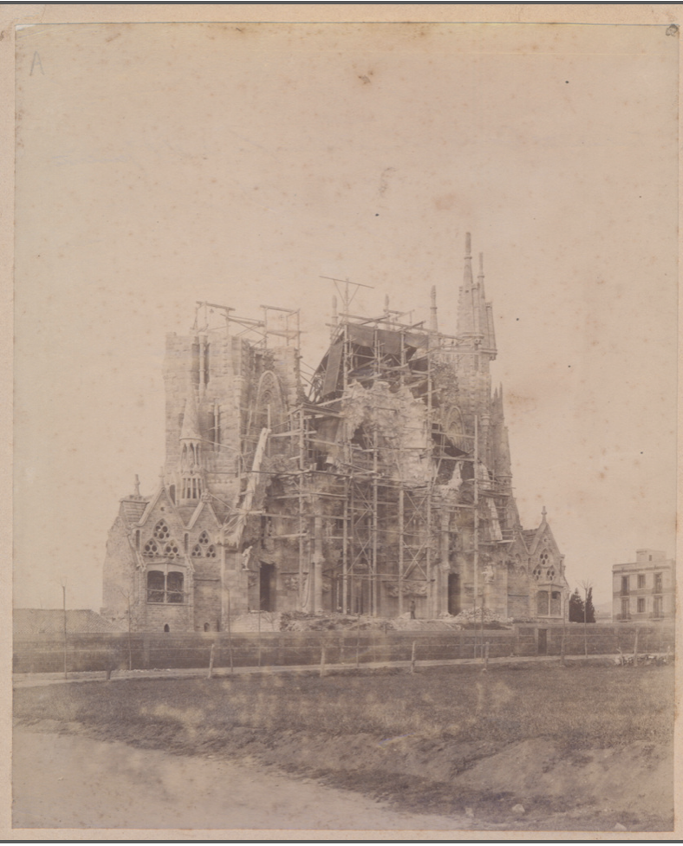

- Nativity Façade, today. https://www.google.com/url?sa=i&url=https%3A%2F%2Flasagradafamiliatickets.com%2Fsagrada-familia-highlights%2F&psig=AOvVaw0r8Bdc7UMzgeBtn3zdLZtt&ust=1614651095487000&source=images&cd=vfe&ved=0CAIQjRxqFwoTCJitw5yCju8CFQAAAAAdAAAAABAD
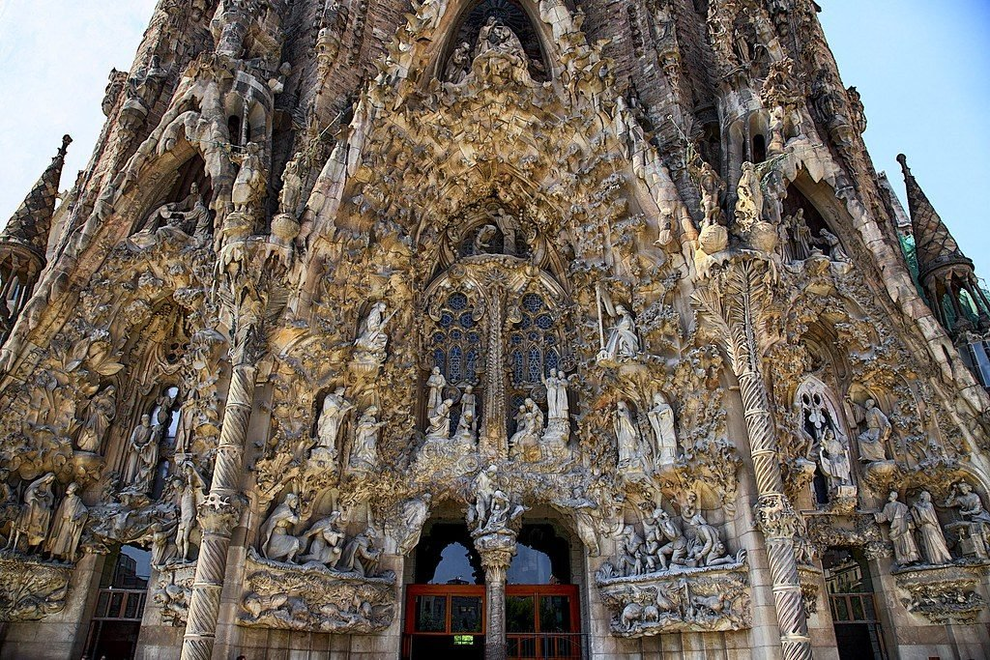

- Inside La Sagrada Familia: Barcelona’s Unfinished Masterpiece, TIME, 28 June 2019, www.youtube.com/watch?v=_di-VI-iKC0.
- “History of the Temple.” La Sagrada Familia, Fundació Junta Constructora Del Temple Expiatori De La Sagrada Família, sagradafamilia.org/en/history-of-the-temple.
- Rasmussen, Steen Eiler. Experiencing Architecture. The MIT Press, 1964.

